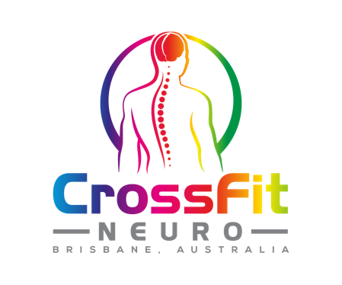
NAME
ADDRESS
DATE OF BIRTH
MOBILE
EMAIL
EMERGENCY CONTACT NAME
EMERGENCY CONTACT NO
OCCUPATION
DATE
MEDICAL INFORMATION
Have you experienced or do you suffer from any of the following illnesses?
Arthritis | Y/N | Dizziness | Y/N
Asthma | Y/N | Epilepsy | Y/N
Diabetes | Y/N | Headaches | Y/N
Heart Disease | Y/N | Head/neck pain | Y/N
Family History of Heart Disease | Y/N | Knee problems | Y/N
High Blood Pressure | Y/N | Back Pain | Y/N
Low Blood Pressure | Y/N | Shoulder pain | Y/N
Shortness of Breath/chest pain | Y/N | Require medications | Y/N
Smoking | Y/N | Alcohol | Y/N

If you ticked on yes to any of the above, please comment below.
________________________________________________________________________________________________________________________________________________________________________________________________________________________________________________________________________________________________________________________________

WAIVER AND RELEASE OF LIABILITY
Functional Movement Training Centre Pty Ltd ACN 610 823 160 CROSSFIT NEURO
CROSSFIT NEURO WAIVER AND RELEASE OF LIABILITY
- I understand that the purpose of this exercise program is to improve my physical and functional fitness. During this program I may perform exercises to improve the capacity of my heart and lungs, my muscle strength and endurance, my joint flexibility, my body composition (amount of fat and lean tissue), my mobility, and my balance.
- I understand and I am aware that I have voluntarily chosen to participate in training activities provided by CrossFit Neuro.
- I understand there are inherent risks in all aspects of physical training.
- I acknowledge that I have been informed of the possible strenuous training and the potential for undesirable physiological results including, but not limited to, abnormal blood pressure, muscle soreness, fainting, heart attack and/ or death.
- I understand that if there are any changes to my medical status that may impact on any part of my training at CrossFit Neuro, it is my responsibility to seek a medical clearance from my treating Doctor and inform staff at CrossFit Neuro as well as submission of medical clearance form to management.
- I understand that the training may involve weightlifting, gymnastics movements, strenuous bodyweight exercises and other high exertion activities, and that I am not obligated to perform nor participate in any activity I do not wish to do; and that it is my right to refuse such participation at any time during my training session.
- I understand that should I feel lightheaded, faint, dizzy, nauseated, or experience pain or discomfort, I am to stop the activity and inform the trainer/ coach. I give CrossFit Neuro and the staff of the facilities I train in, permission to seek emergency medical services for me should I become injured or ill with the understanding that I am responsible for any expenses incurred.
- I agree to RELEASE THE RELEASEES from any and all liability for any loss, damage, injury or expense that I may suffer, or that my next of kin may suffer as a result of my participation in the programs, activities and services provided by CrossFit Neuro.
- I agree to HOLD HARMLESS AND INDEMNIFY THE RELEASEEES from any and all liability for any damage to the property of, or personal injury to, any third party resulting from my participation in any program, activity or service provided by the releasees.
- I understand I must notify CrossFit Neuro in writing by 23rd of the month if any changes or cancellations are requested for the following month.
- I understand a minimum hold time on my monthly fee is 2 weeks and a maximum hold of 3 x per year is only permitted.
This agreement shall be binding upon me, my successors, representatives, heirs, executors, assigns, or transferees. If any portion of this agreement is held invalid, I agree that the remainder of the agreement shall remain in full legal force and effect. If I am signing on behalf of a minor child, I also give full permission for any person connected with CrossFit Neuro to administer first aid deemed necessary, and in case of serious illness or injury, I give permission to call for medical and or surgical care for the child and to transport the child to a medical facility deemed necessary for the well being of the child.
Use of photo / film likeness. I agree to allow CrossFit Neuro, its agents, principals, volunteers and employees to use photo(s), film and /or likeness of me for advertising purposes. In the event I choose not to allow the use of the same for said purpose, I agree that I must inform CrossFit Neuro of this in writing.
I HAVE READ AND UNDERSTOOD THIS AGREEMENT AND I AM AWARE THAT BY SIGNING THIS ‘INFORMED CONSENT FORM’ I AM WAIVING CERTAIN LEGAL RIGHTS (INLUDING THE RIGHT TO SUE) WHICH I OR MY HEIRS, NEXT OF KIN, EXECUTOR, ADMINISTERS AND ASSIGNS MAY HAVE AGAINST THE RELEASEES. ANY QUESTION I HAD WERE ANSWERED TO MY FULL SATISFACTION.

