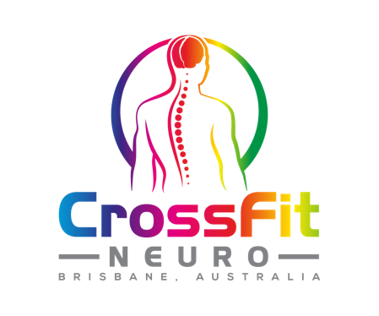
NAME
ADDRESS
DATE OF BIRTH
MOBILE
EMAIL
EMERGENCY CONTACT NAME
EMERGENCY CONTACT NO
OCCUPATION
DATE
MEDICAL INFORMATION
Have you experienced or do you suffer from any of the following illnesses?
Arthritis | Y/N | Dizziness | Y/N
Asthma | Y/N | Epilepsy | Y/N
Diabetes | Y/N | Headaches | Y/N
Heart Disease | Y/N | Head/neck pain | Y/N
Family History of Heart Disease | Y/N | Knee problems | Y/N
High Blood Pressure | Y/N | Back Pain | Y/N
Low Blood Pressure | Y/N | Shoulder pain | Y/N
Shortness of Breath/chest pain | Y/N | Require medications | Y/N
Smoking | Y/N | Alcohol | Y/N

If you ticked on yes to any of the above, please comment below.
________________________________________________________________________________________________________________________________________________________________________________________________________________________________________________________________________________________________________________________________

WAIVER AND RELEASE OF LIABILITY
Functional Movement Training Centre Pty Ltd ACN 610 823 160
FUNCTIONAL MOVEMENT TRAINING CENTRE 2 WAIVER AND RELEASE OF LIABILITY
- I understand that the purpose of this exercise program is to improve my physical and functional fitness. During this program I may perform exercises to improve the capacity of my heart and lungs, my muscle strength and endurance, my joint flexibility, my body composition (amount of fat and lean tissue), my mobility, and my balance. The programmed classes will meet for 8 weeks, two times per week for 60 minutes. Each class will be instructed and supervised by personnel with extensive education and experience in exercise science and managing low back pain.
- I understand and I am aware that I have voluntarily chosen to participate in training activities provided by Functional Movement Training Centre.
- I understand there are inherent risks in all aspects of physical training.
- I acknowledge that I have been informed of the possible strenuous training and the potential for
undesirable physiological results including, but not limited to, abnormal blood pressure, muscle
soreness, fainting, heart attack and/ or death.
- I understand that the training may involve weightlifting, gymnastics movements, strenuous
bodyweight exercises and other high exertion activities, and that I am not obligated to perform nor participate in any activity I do not wish to do; and that it is my right to refuse such participation at any time during my training session.
- I understand that should I feel lightheaded, faint, dizzy, nauseated, or experience pain or discomfort, I am to stop the activity and inform the trainer/ coach. I give Functional Movement Training Centre and the staff of the facilities I train in, permission to seek emergency medical services for me should I become injured or ill with the understanding that I am responsible for any expenses incurred. Initial _____________
- I agree to RELEASE THE RELEASEES from any and all liability for any loss, damage, injury or expense that I may suffer, or that my next of kin may suffer as a result of my participation in the programs, activities and services provided by Functional Movement Training Centre
- I agree to HOLD HARMLESS AND INDEMNIFY THE RELEASEEES from any and all liability for any damage to the property of, or personal injury to, any third party resulting from my participation in any program, activity or service provided by the releasees. Initials _____________
This agreement shall be binding upon me, my successors, representatives, heirs, executors, assigns, or transferees. If any portion of this agreement is held invalid, I agree that the remainder of the agreement shall remain in full legal force and effect. If I am signing on behalf of a minor child, I also give full permission for any person connected with Functional Movement Training Centre to administer first aid deemed necessary, and in case of serious illness or injury, I give permission to call for medical and or surgical care for the child and to transport the child to a medical facility deemed necessary for the well being of the child. Initial _____________
Use of photo / film likeness. I agree to allow Functional Movement Training Centre, its agents, principals, volunteers and employees to use photo(s), film and /or likeness of me for advertising purposes. In the event I choose not to allow the use of the same for said purpose, I agree that I must inform Functional Movement Training Centre of this in writing. Initials _______________
I HAVE READ AND UNDERSTOOD THIS AGREEMENT AND I AM AWARE THAT BY SIGNING THIS ‘INFORMED CONSENT FORM’ I AM WAIVING CERTAIN LEGAL RIGHTS (INLUDING THE RIGHT TO SUE) WHICH I OR MY HEIRS, NEXT OF KIN, EXECUTOR, ADMINISTERS AND ASSIGNS MAY HAVE AGAINST THE RELEASEES. ANY QUESTION I HAD WERE ANSWERED TO MY FULL SATISFACTION.
Signature of Participant ____________________________ Date ________________________

